Practical 1: Getting Started with Tableau and Building Basic Visualizations

Aim
To understand the Tableau interface, connect to datasets, create basic visualizations, and build an interactive dashboard.

Software Required
- Tableau Desktop / Tableau Public
- Sample Superstore Dataset (CSV)
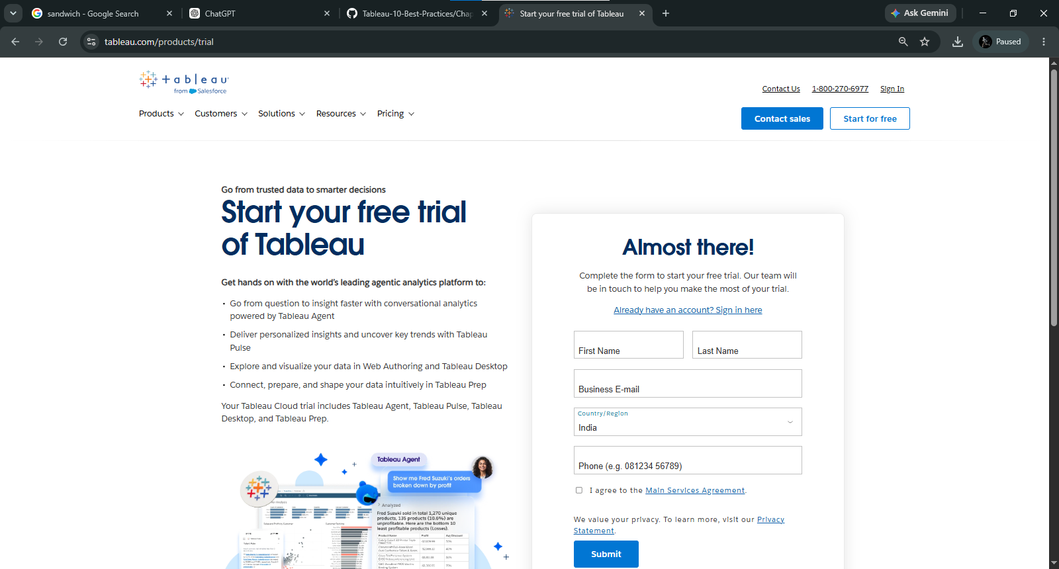

Dataset
Sample - Superstore.csv
Common fields:
- Order Date
- Sales
- Profit
- Quantity
- Category
- Sub-Category
- Region
- State
- Customer Name
Dataset: C:\Users\admin\Downloads\sample_-_superstore (1).xls

(a) Connect to a CSV Dataset and Explore the Tableau Interface

Procedure

Step 1
Open Tableau Desktop/Public.
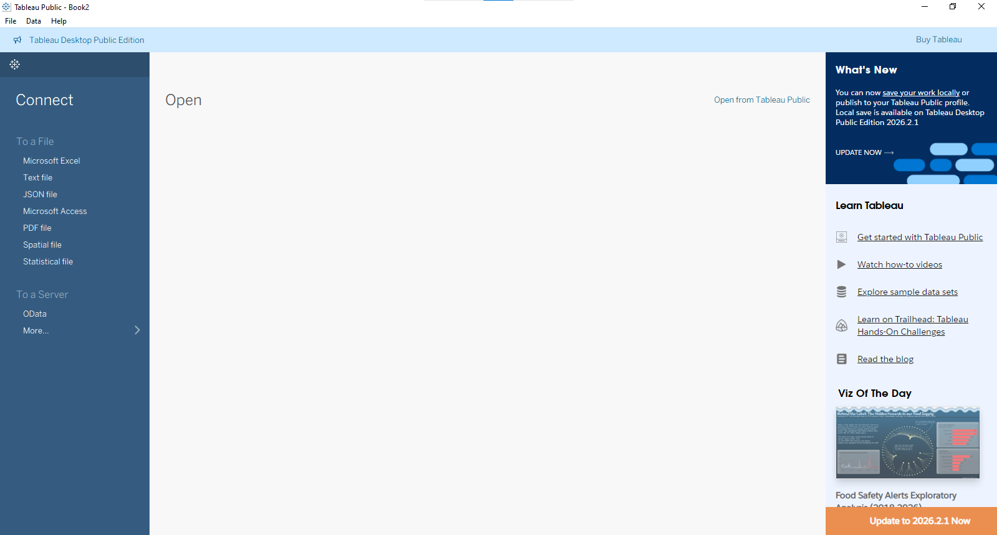

Step 2
Click
Connect → Text File
Browse and select
Sample-Superstore.csv
Click Open.
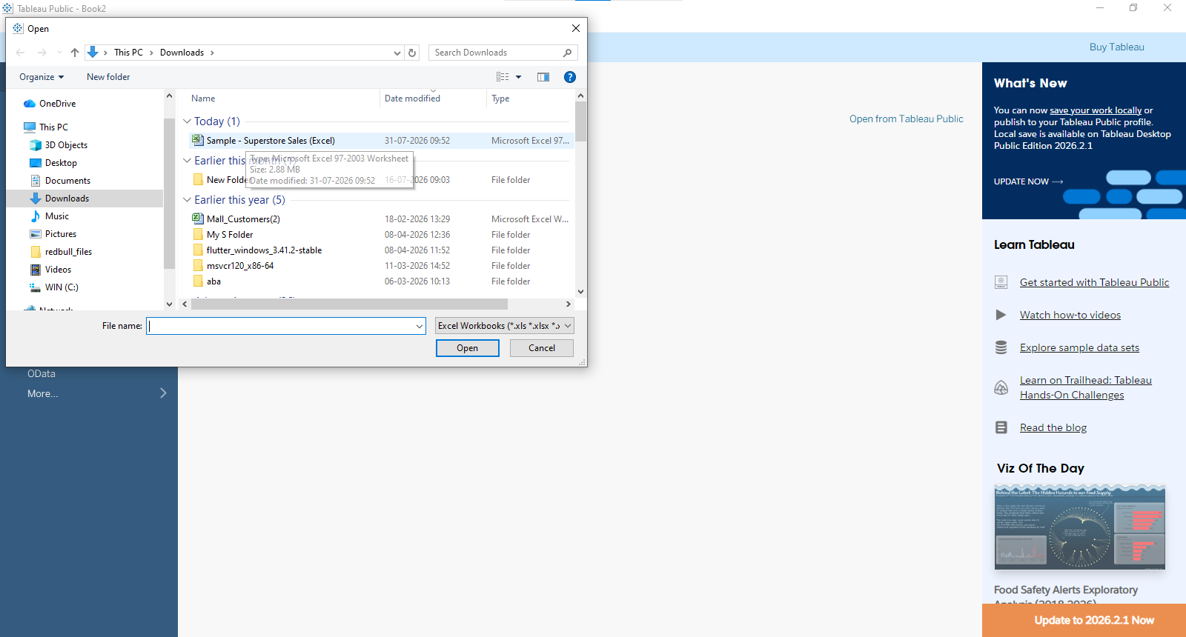

Step 3
Tableau loads the data preview.
Click
Sheet 1
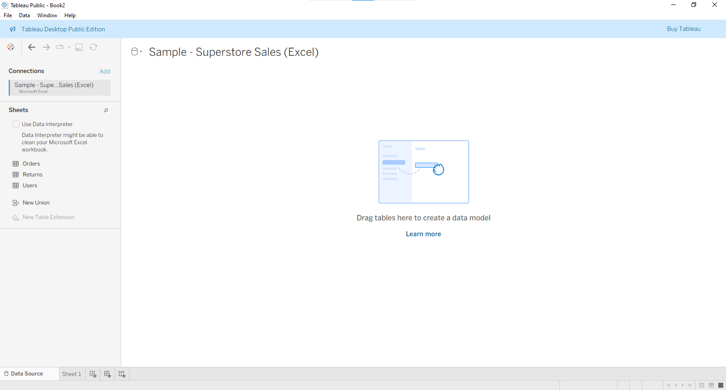

Tableau Interface
- Data Pane
- Analytics Pane
- Columns Shelf
- Rows Shelf
- Marks Card
- Filters Shelf
- Pages Shelf
- Toolbar
- Show Me Panel

Observation
The dataset is successfully connected and all fields appear in the Data Pane.

(b) Identify and Differentiate Measures and Dimensions

Dimensions
Represent qualitative/categorical data.
Examples
- Category
- Region
- State
- Customer Name
Displayed in Blue

Measures
Represent numerical values.
Examples
- Sales
- Profit
- Quantity
- Discount
Displayed in Green

Difference
Dimension | Measure
Categorical | Numerical
Creates headers | Creates axes
Used for grouping | Used for calculations
Blue | Green

(c) Convert Fields Between Discrete and Continuous
Example using Sales

Continuous
Right-click Sales
Choose
Continuous
Produces a numeric axis.

Discrete
Right-click Sales
Choose
Discrete
Produces separate headers.

Observation
Continuous creates graphs with axes.
Discrete creates category labels.
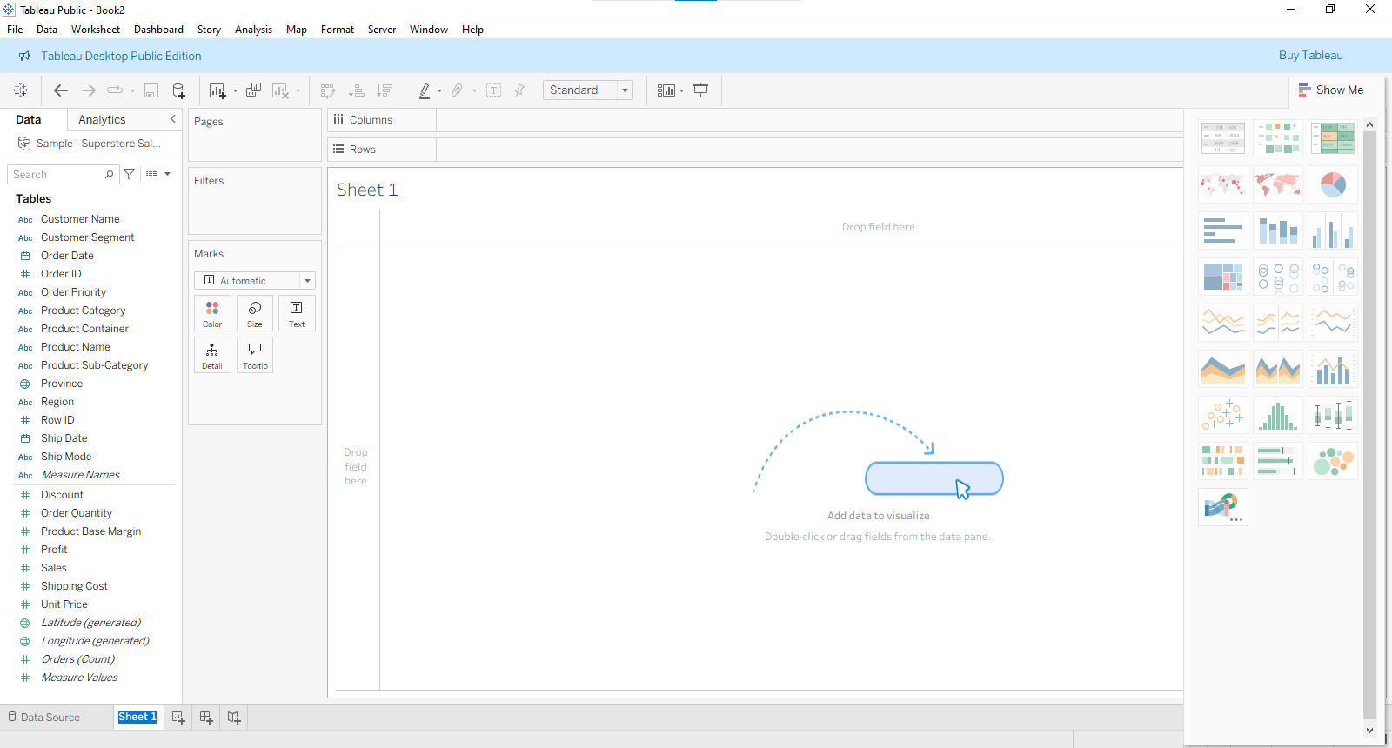

(d) Create and Customize a Basic Bar Chart

Procedure
Drag
Category
to Rows.
Drag
Sales
to Columns.

Choose
Bar
from Show Me.
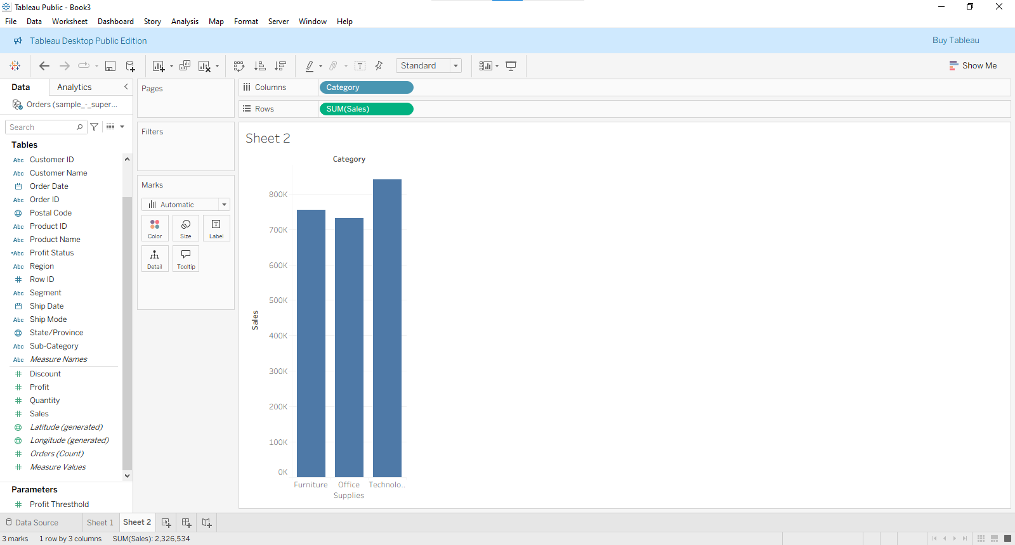

Customization
Drag
Profit
to Color.
Drag
Sales
to Label.
Sort descending.
Change colors.
Increase font size.

Output
Bar chart showing Sales by Category.
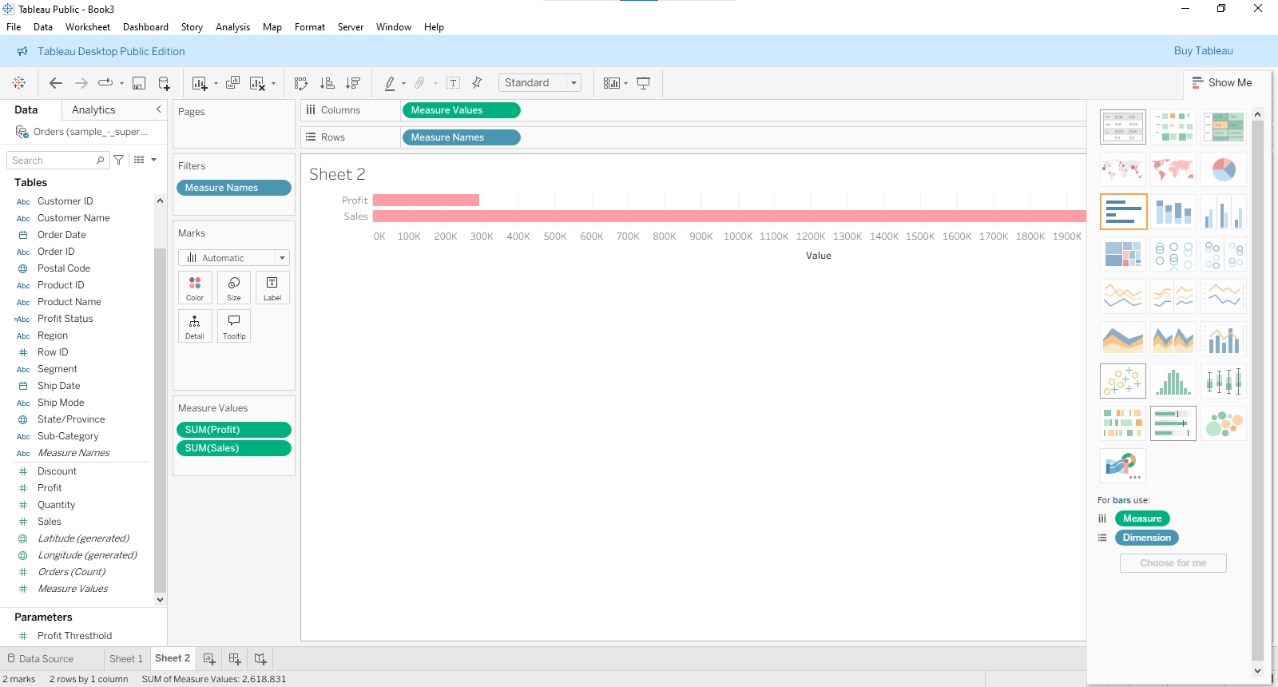

(e) Build a Line Chart for Time-Series Analysis
Drag
Order Date
to Columns.
Select
Month
Drag
Sales
to Rows.
Choose
Line

Observation
A line chart displays monthly sales trends.
Useful for trend analysis.
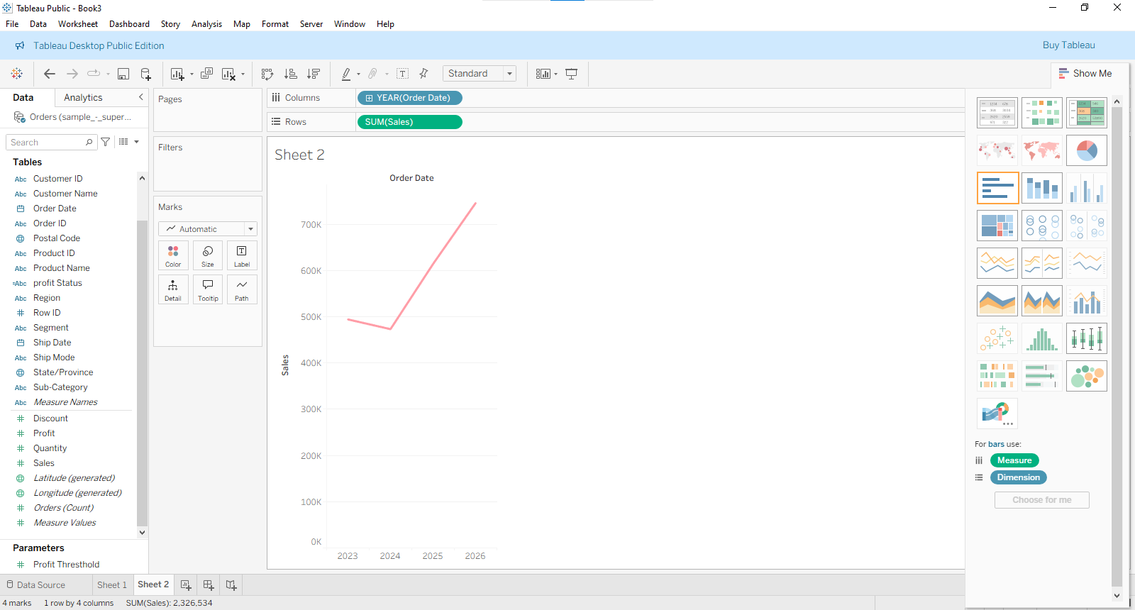

(f) Create a Geographic Map Visualization
Drag
State
onto the canvas.
Tableau automatically generates Latitude and Longitude.

Drag
Sales
to Color.
Drag
Profit
to Size.

Observation
States with higher sales appear darker and larger.
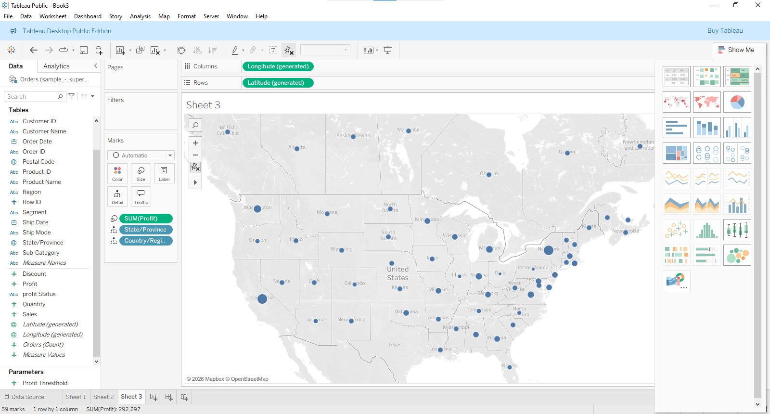

(g) Combine Multiple Charts into an Interactive Dashboard

Step 1
Click
Dashboard → New Dashboard

Step 2
Drag
- Bar Chart
- Line Chart
- Map
onto the dashboard.

Step 3
Click
Use as Filter
on the Bar Chart.
Now selecting a category filters all other charts.

Final Dashboard
Contains
- Sales by Category
- Monthly Sales Trend
- Sales by State
Interactive filtering enabled.

Practical 2: Working with Data Sources and Data Preparation in Tableau

Aim
To understand Tableau data connections, data preparation, joins, blending, filtering, and performance optimization.

Software Required
- Tableau Desktop/Public
- Excel File
- CSV File
- SQL Database (optional)

(a) Connect to Different Data Sources

CSV
Connect → Text File

Excel
Connect → Microsoft Excel

Database
Examples
- SQL Server
- MySQL
- PostgreSQL
- Oracle
Enter
- Server
- Username
- Password
Click
Sign In

Observation
Tableau connects to multiple data sources.

(b) Create Data Extracts vs Live Connections

Live Connection
Reads data directly from the database.
Advantages
- Real-time data
- Always updated
Disadvantages
- Slower

Extract
Stores data locally.
Create Extract
Data → Extract Data
Save
.hyper
file.
Advantages
- Faster
- Offline usage
Disadvantages
- Needs refresh

Difference
Live | Extract
Real-time | Snapshot
Slower | Faster
Needs DB connection | Offline
Always updated | Manual refresh

(c) Manage Metadata

Rename Field
Right-click field
Rename
Example
Sales → Total Sales
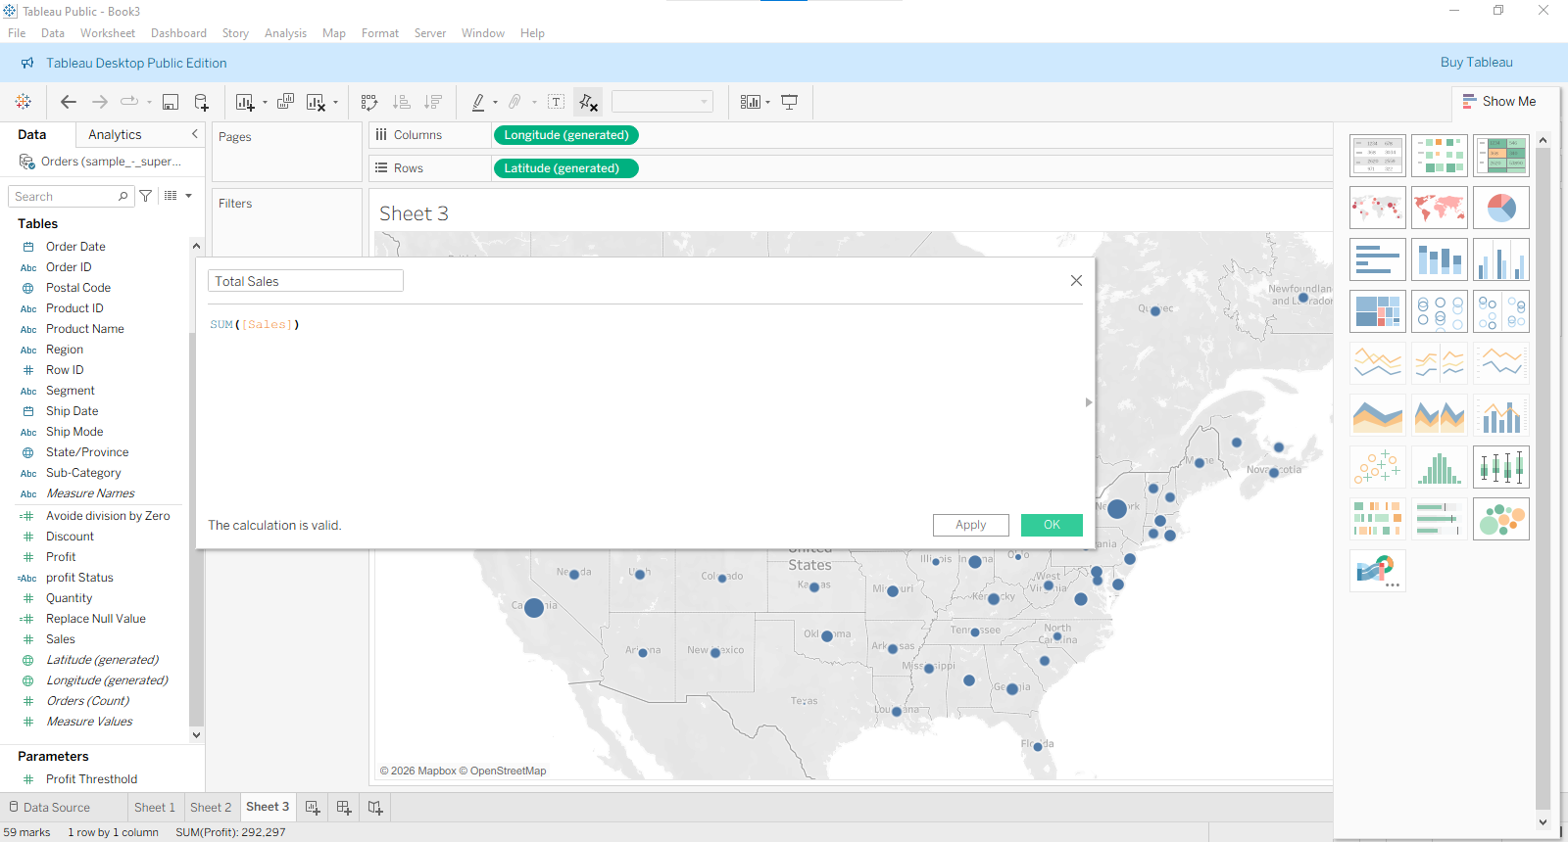

Hide Field
Right-click
Hide
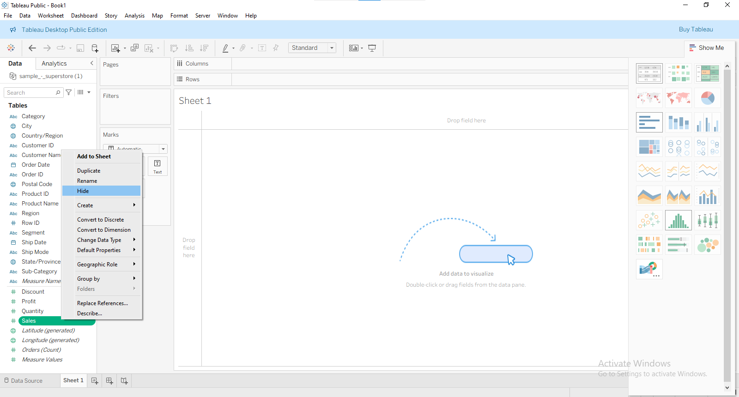

Change Data Type
Right-click field
Change Data Type
Options
- String
- Number
- Date
- Boolean
- Geographic
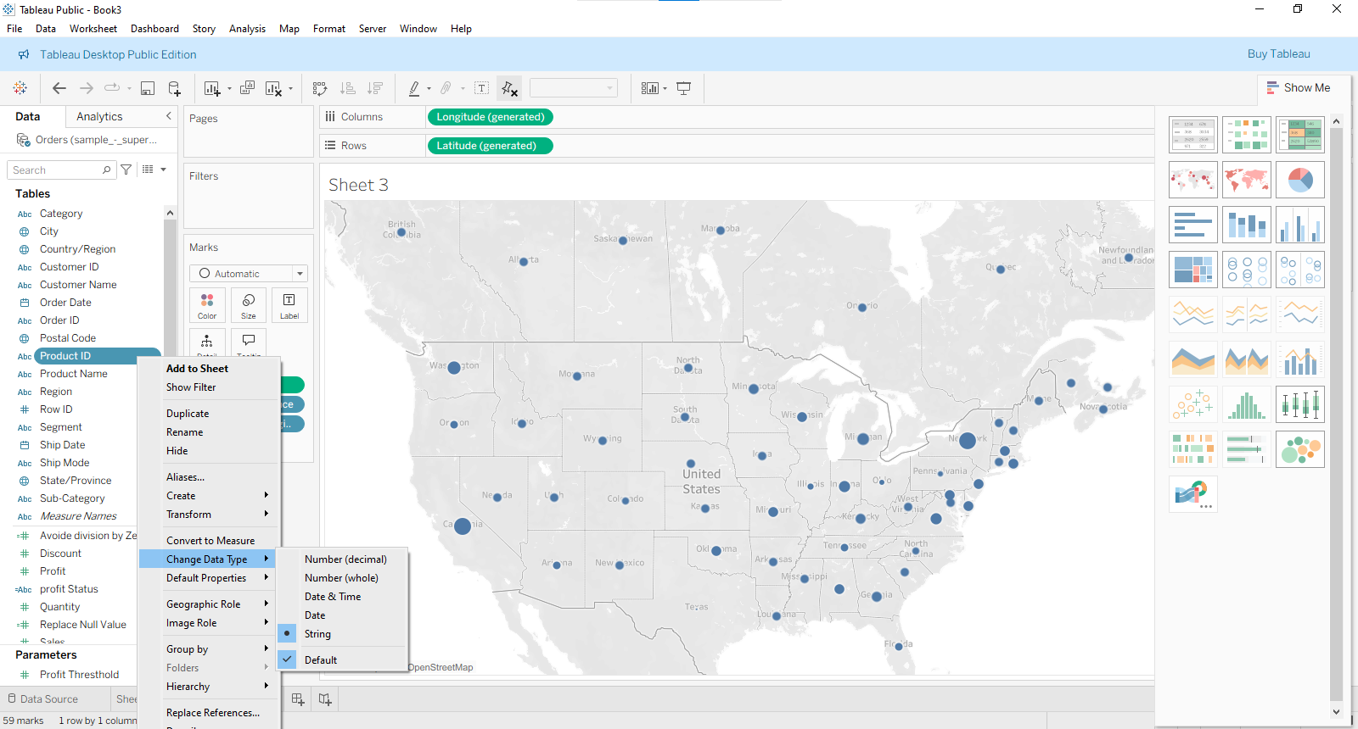

Observation
Metadata management improves readability and analysis.

(d) Perform Joins
Suppose
Orders.csv
| Order ID | Customer ID | Sales |
Customers.csv
| Customer ID | Customer Name |

Drag both tables onto the Data Source page.
Choose Join.

Inner Join
Returns matching records only.
Orders.CustomerID =
Customers.CustomerID
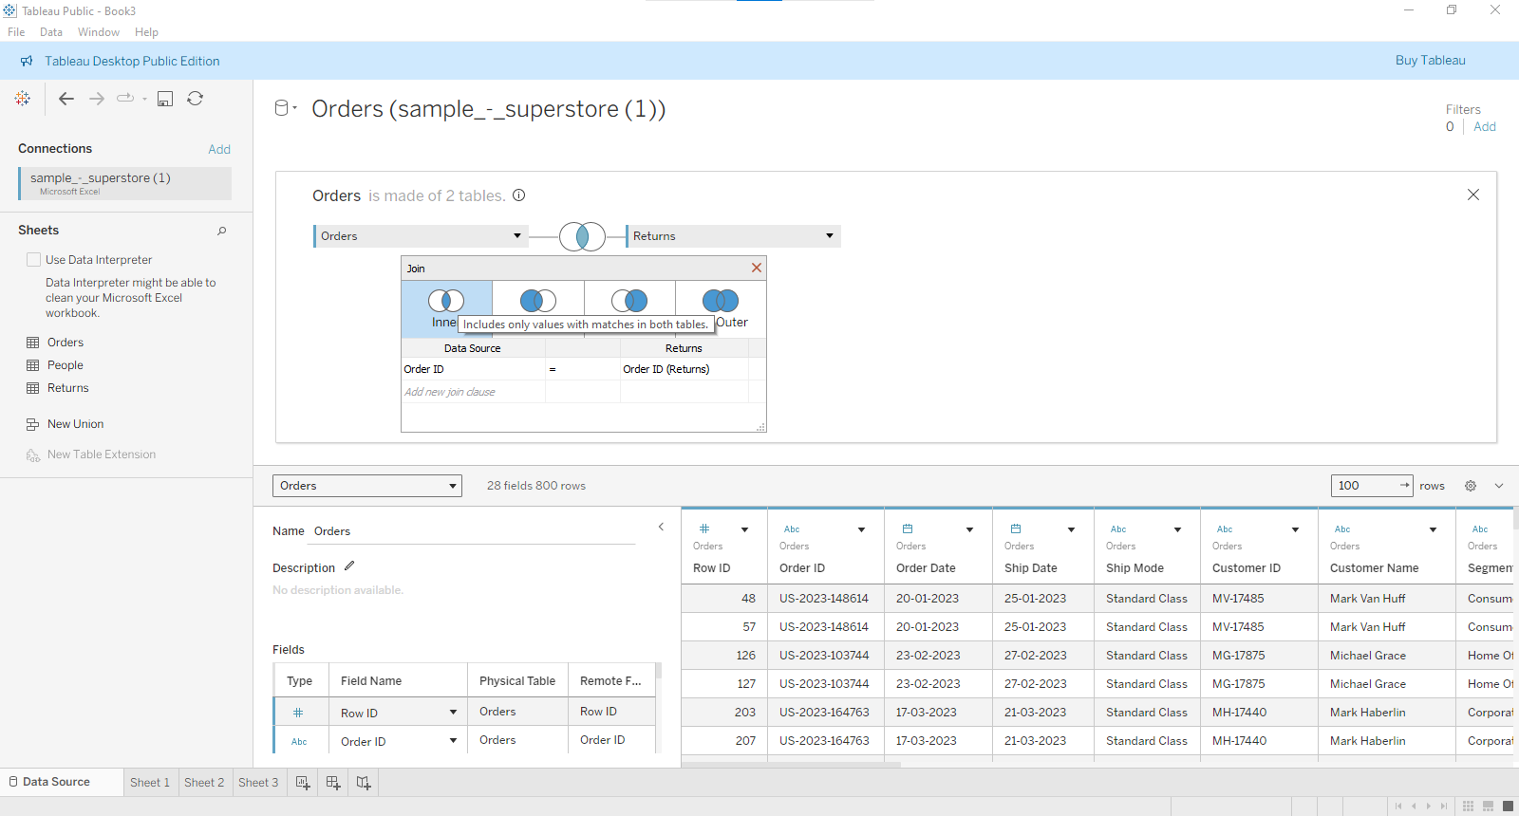

Left Join
Returns all rows from Orders.
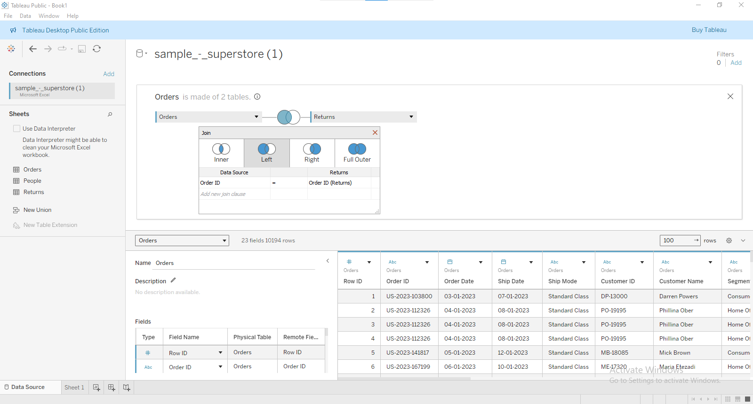

Right Join
Returns all rows from Customers.
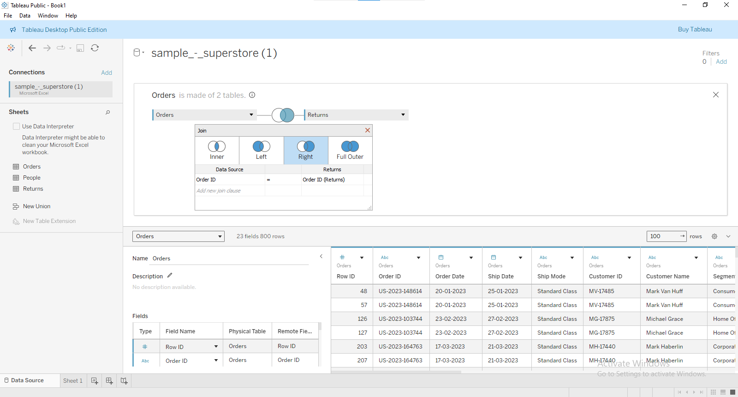

Join Comparison
Join | Returns
Inner | Matching records
Left | All left records
Right | All right records

(e) Apply Data Blending
Example
Primary Source
Sales Data
Secondary Source
Targets Data
Connect both.
Relate using
Region
Enable the chain-link icon.
Now compare
Sales vs Target

Difference
Join | Blend
Before analysis | During analysis
Same source | Different sources
Faster | Flexible

(f) Implement Different Types of Filters

Dimension Filter
Example
Region = West

Measure Filter
Example
Sales > 10000

Date Filter
Example
Year = 2024

Filter Shelf
Drag desired field to
Filters
Choose filter values.

(g) Optimize Performance

1. Use Extracts
Faster than live.

2. Hide Unused Fields
Reduces memory usage.

3. Apply Filters Early
Reduces records loaded.

4. Reduce Marks
Avoid plotting millions of marks.

5. Aggregate Data
Summarize before visualization.

6. Avoid Complex Calculations
Simplify calculated fields where possible.

7. Limit Dashboard Components
Use fewer worksheets and filters.

Practical 3: Creating Advanced Visualizations in Tableau

Aim
To create advanced visualizations in Tableau using the Sample Superstore dataset.

Software Required
- Tableau Desktop / Tableau Public
- Sample Superstore dataset

Step 1: Open the Dataset
- Open Tableau Public/Desktop.
- Click Connect → Microsoft Excel.
- Select Sample - Superstore.xls.
- Drag the Orders sheet to the canvas.
- Click Sheet 1.

(a) Create Stacked and Grouped Bar Charts

1. Stacked Bar Chart

Objective
Compare Sales by Category and Sub-Category.

Steps
- Open a new worksheet.
- Drag Category → Rows.
- Drag Sales → Columns.
- Drag Sub-Category → Color on the Marks card.
- Click Show Me.
- Select Stacked Bars.
- Rename worksheet as Stacked Bar Chart.

Result
Each category is divided into colored sub-categories.

2. Grouped (Side-by-Side) Bar Chart

Steps
- New Worksheet.
- Drag Category → Columns.
- Drag Region beside Category.
- Drag Sales → Rows.
- Choose Bar under Marks.
- Give different colors to Region.

Result
Each category displays separate bars for each region.

(b) Build Treemaps and Pie Charts

Treemap

Objective
Show Sales contribution by Sub-Category.

Steps
- New Worksheet.
- Drag Sub-Category → Marks → Label.
- Drag Sales → Size.
- Drag Profit → Color.
- Click Show Me.
- Choose Treemap.

Result
Large rectangles indicate higher sales.

Pie Chart

Objective
Display Sales distribution by Category.

Steps
- New Worksheet.
- Change Marks to Pie.
- Drag Category → Color.
- Drag Sales → Angle.
- Drag Sales → Label.
- Click Label → Show Mark Labels.

Result
Each slice represents category sales.

(c) Design Scatter Plot

Objective
Find relationship between Sales and Profit.

Steps
- New Worksheet.
- Drag Sales → Columns.
- Drag Profit → Rows.
- Drag Sub-Category → Detail.
- Drag Category → Color.
- Click Show Me → Scatter Plot.
(Optional)
- Open Analytics pane.
- Drag Trend Line onto the chart.

Result
Relationship between Sales and Profit becomes visible.

(d) Create Dual-Axis and Combination Charts

Dual-Axis Chart

Objective
Compare Sales and Profit together.

Steps
- New Worksheet.
- Drag Order Date → Columns.
- Change Order Date to Year.
- Drag Sales → Rows.
- Drag Profit beside Sales on Rows.
- Right-click second axis.
- Select Dual Axis.
- Right-click axis.
- Choose Synchronize Axis.
- Change Sales to Bar and Profit to Line.

Result
Bars show Sales while line shows Profit.

Combination Chart

Steps
- Keep Dual Axis.
- On Marks card:
  - Sales = Bar
  - Profit = Line
- Give different colors.

Result
Bar and Line chart appear together.

(e) Develop Histogram

Objective
Analyze Sales distribution.

Steps
- New Worksheet.
- Right-click Sales.
- Choose Create → Bins.
- Keep default bin size.
- Click OK.
- Drag Sales (bin) → Columns.
- Drag Number of Records → Rows.
- Click Show Me → Histogram.

Result
Displays frequency of sales values.

(f) Build Box-and-Whisker Plot

Objective
Identify outliers in Sales.

Steps
- New Worksheet.
- Drag Category → Columns.
- Drag Sales → Rows.
- Click Show Me.
- Select Box-and-Whisker Plot.
Alternative Method
- Create Bar Chart.
- Open Analytics pane.
- Drag Box Plot into the view.
- Drop on Cell.

Result
Shows
- Minimum
- First Quartile
- Median
- Third Quartile
- Maximum
- Outliers

(g) Create Gantt Chart and Advanced Date Visualizations

Gantt Chart

Objective
Show shipping duration.

Steps
- New Worksheet.
- Drag Order ID → Rows.
- Drag Order Date → Columns.
- Change Marks type to Gantt Bar.
- Create Calculated Field
Shipping Days

DATEDIFF('day',[Order Date],[Ship Date])
- Drag Shipping Days → Size.
- Drag Ship Mode → Color.

Practical 4: Performing Data Analysis using Calculations in Tableau

Dataset
Use Sample - Superstore.xls (available in Tableau Public).

(a) Create Basic Calculated Fields Using Formulas

Objective
Create new fields using mathematical formulas.

Steps

Step 1
Open Tableau.

Step 2
Connect to Sample Superstore dataset.

Step 3
Go to Analysis → Create Calculated Field.

Step 4
Name it
Profit Ratio

Formula
SUM([Profit]) / SUM([Sales])
Click OK.

Create another field
Name
Discount Amount
Formula
[Sales] * [Discount]

Create another field
Profit Category
Formula
IF [Profit] > 0 THEN
"Profit"
ELSE
"Loss"
END

Visualization
Rows → Category
Columns → Profit Ratio
Color → Profit Category

Output
You can now compare profit ratio across product categories.

(b) Perform Row-Level Calculations

Objective
Calculate values for every individual row.

Step 1
Create Calculated Field
Name
Net Sales
Formula
[Sales] - ([Sales] * [Discount])

Step 2
Create another field
Tax
Formula
[Sales] * 0.18

Step 3
Create another field
Final Amount
Formula
([Sales]-([Sales]*[Discount]))+[Sales]*0.18

Build Chart
Rows → Customer Name
Columns → Final Amount

Output
Shows final amount paid by every customer.

(c) Perform Aggregate-Level Calculations
Aggregate calculations summarize multiple rows.

Step 1
Create Calculated Field
Average Sales
Formula
AVG([Sales])

Step 2
Create
Total Profit
Formula
SUM([Profit])

Step 3
Create
Average Discount
Formula
AVG([Discount])

Create View
Rows
Category
Columns
Average Sales
Label
Total Profit

Output
Displays average sales and total profit for every category.

(d) Implement FIXED Level of Detail (LOD)

Objective
Find sales irrespective of filters or visualization level.

Step 1
Create Calculated Field
Name
Region Sales
Formula
{ FIXED [Region] :
SUM([Sales])
}

Step 2
Build View
Rows
Region
Columns
Region Sales

Result
Every state in the same region displays identical regional sales.

Example
Region | State | Region Sales
East | New York | 732,000
East | Pennsylvania | 732,000
East | Ohio | 732,000

(e) Use INCLUDE and EXCLUDE LOD Expressions

INCLUDE
Calculates by including extra dimension.

Create
Customer Sales
Formula
{
INCLUDE [Customer Name]:
SUM([Sales])
}

Visualization
Rows
Category
Columns
Customer Sales

Result
Sales calculated at customer level before aggregation.

EXCLUDE
Ignores one dimension.
Create
Category Sales
Formula
{
EXCLUDE [Sub-Category]:
SUM([Sales])
}

Visualization
Rows
Category
Sub-Category
Columns
Category Sales

Result
All Sub-Categories under same Category show identical total sales.

(f) Create and Use Parameters for Dynamic Analysis

Objective
Allow users to interact with dashboard.

Step 1
Right Click
Create Parameter

Name
Profit Threshold

Data Type
Float

Current Value
1000

Minimum
0

Maximum
5000

Step 2
Create Calculated Field
Profit Status
Formula
IF SUM([Profit])>[Profit Threshold]
THEN
"High Profit"
ELSE
"Low Profit"
END

Step 3
Drag
Category
Profit Status
to visualization.

Step 4
Right-click Parameter
Show Parameter
Move slider.

Output
Visualization changes dynamically.

(g) Apply Calculations to Fix Data Issues and Enhance Insights

Example 1
Replace Null Values
Formula
IFNULL([Profit],0)

Example 2
Avoid Division by Zero
IF SUM([Sales])=0 THEN
0
ELSE
SUM([Profit])/SUM([Sales])
END

Example 3
Categorize Sales
IF [Sales]>1000 THEN
"High"
ELSEIF [Sales]>500 THEN
"Medium"
ELSE
"Low"
END

Example 4
Extract Year
YEAR([Order Date])

Example 5
Profit Percentage
(SUM([Profit])/SUM([Sales]))*100

Practical 5: Analyzing Data Using Table Calculations in Tableau
Dataset: Tableau Sample Superstore
Recommended fields: Order Date, Sales, Profit, Category, Sub-Category, Region, State, Customer Name.

Aim
To analyze the Superstore dataset using Table Calculations in Tableau, including running totals, percentages, moving averages, year-over-year growth, ranking, window functions, partitioning, and dynamic labels.

a) Apply Quick Table Calculations

1. Running Total
A Running Total continuously adds values from the beginning of the table.

Steps
- Open Tableau and connect to Sample Superstore.
- Create a new worksheet.
- Drag Order Date to Columns.
- Right-click Order Date → select Month.
- Drag Sales to Rows.
- Click the drop-down arrow on SUM(Sales) in the Rows shelf.
- Select:
Quick Table Calculation → Running Total.
- Tableau will now show cumulative sales over time.

Example
Month | Sales | Running Total
Jan | 10,000 | 10,000
Feb | 12,000 | 22,000
Mar | 15,000 | 37,000
Apr | 11,000 | 48,000
Use: Useful for understanding how total sales accumulate throughout the year.

2. Percent of Total
This calculates each value as a percentage of the overall total.

Steps
- Drag Category to Rows.
- Drag Sales to Columns.
- Click the drop-down arrow on SUM(Sales).
- Select:
Quick Table Calculation → Percent of Total.
- Format the result as a percentage if required.

Example
Category | Sales | % of Total
Technology | 100,000 | 40%
Furniture | 80,000 | 32%
Office Supplies | 70,000 | 28%
Use: Helps identify which category contributes most to total sales.

b) Create Moving Averages and Cumulative Metrics

1. Moving Average
A Moving Average calculates the average of the current value and a specified number of previous values.

Steps
- Drag Order Date to Columns.
- Select Month.
- Drag Sales to Rows.
- Click the SUM(Sales) drop-down.
- Select:
Quick Table Calculation → Moving Average.
- Right-click the calculated field → Edit Table Calculation.
- Set:
  - Previous values = 2
  - Next values = 0
This produces a 3-month moving average including the current month.

Formula
For a 3-month moving average:
Moving Average=3Salest​+Salest−1​+Salest−2​​

Example
If sales are:
- January = 10,000
- February = 12,000
- March = 15,000
Then:
MA=310000+12000+15000​ MA=12,333.33
Use: Helps smooth fluctuations and identify sales trends.

2. Cumulative Metrics
A cumulative metric shows the accumulated value over time.

Example: Cumulative Profit
- Drag Order Date → Columns.
- Select Month.
- Drag Profit → Rows.
- Select:
Quick Table Calculation → Running Total.
- Rename the worksheet to Cumulative Profit Analysis.
This gives the cumulative profit generated over time.

c) Perform Year-over-Year Growth Analysis
Year-over-Year (YoY) growth compares a value with the corresponding value from the previous year.

Steps
- Drag Order Date to Columns.
- Select YEAR(Order Date).
- Drag Sales to Rows.
- Click the drop-down arrow on SUM(Sales).
- Select:
Quick Table Calculation → Year-over-Year Growth.
If this option is not directly visible:
- Select Quick Table Calculation.
- Choose Percent Difference From.
- Set:
  - Relative to: Previous
  - Compute using: Table Across

Formula
YoY Growth=Previous Year SalesCurrent Year Sales−Previous Year Sales​×100

Example
2023 Sales = ₹100,000
2024 Sales = ₹120,000
YoY=100000120000−100000​×100 YoY=20%
Therefore, sales increased by 20%.

d) Use Ranking Functions — Top N and Bottom N
Ranking is useful for identifying the best- and worst-performing products, customers, states, etc.

1. Rank Products by Sales

Steps
- Drag Sub-Category to Rows.
- Drag Sales to Columns.
- Sort the chart in descending order.
- For an explicit table calculation:
  - Drag Sales to the view again.
  - Right-click the second SUM(Sales).
  - Select:
Quick Table Calculation → Rank.
You can then see the rank of each sub-category.

Example
Sub-Category | Sales | Rank
Phones | 330,000 | 1
Chairs | 328,000 | 2
Storage | 223,000 | 3
Tables | 206,000 | 4

2. Top N Products
To show only the Top 10:
- Drag Product Name to Rows.
- Drag Sales to Columns.
- Right-click Product Name.
- Select Filter.
- Open the Top tab.
- Select:
By field → Top 10 → Sales → Sum.
- Click OK.
This displays the 10 products with the highest sales.

Bottom N
Repeat the process but select:
Bottom → 10 → Sales → Sum
This identifies the 10 products with the lowest sales.

e) Implement Window Functions
Window functions perform calculations across a specified range of rows.
Two important functions are:
- WINDOW_SUM()
- WINDOW_AVG()

1. WINDOW_SUM()

Formula
WINDOW_SUM(SUM([Sales]), -2, 0)
This calculates the sum of:
- 2 previous values
- Current value
Therefore, it creates a 3-period window sum.

Steps
- Select Analysis → Create Calculated Field.
- Enter:
WINDOW_SUM(SUM([Sales]), -2, 0)
- Name it:
3 Month Window Sales
4. Click OK.
5. Drag Order Date → Columns.
6. Drag Sales → Rows.
7. Drag 3 Month Window Sales to the view.

2. WINDOW_AVG()

Formula
WINDOW_AVG(SUM([Sales]), -2, 0)
It calculates the average of the current value and the previous two values.

Steps
- Select Analysis → Create Calculated Field.
- Enter:
WINDOW_AVG(SUM([Sales]), -2, 0)
- Name it:
3 Month Moving Average
4. Click OK.
5. Add it to the worksheet.

Example
Month | Sales | Window Average
Jan | 10,000 | 10,000
Feb | 12,000 | 11,000
Mar | 15,000 | 12,333
Apr | 11,000 | 12,667

f) Customize Addressing and Partitioning
This is one of the most important concepts in table calculations.

Addressing
Addressing determines the direction in which Tableau performs the calculation.
For example:
- Table Across
- Table Down
- Pane Across
- Pane Down
- Specific Dimensions

Partitioning
Partitioning determines where Tableau restarts the calculation.
For example, if the calculation is partitioned by Region, Tableau calculates a separate running total for:
- Central
- East
- South
- West

Example: Running Sales by Region

Steps
- Drag Region to Rows.
- Drag Order Date to Columns.
- Select Month.
- Drag Sales to Rows.
- Apply:
Quick Table Calculation → Running Total.
- Right-click the calculated field.
- Select Edit Table Calculation.
- Under Compute Using, choose Specific Dimensions.
- Select Order Date.
- Keep Region as the partition.
Now Tableau calculates a separate running total for each region.

Concept
East:
Jan → Feb → Mar → Apr

West:
Jan → Feb → Mar → Apr

Central:
Jan → Feb → Mar → Apr

South:
Jan → Feb → Mar → Apr
Each region starts its own calculation.

g) Create Dynamic Titles and Labels Using Table Calculations
Dynamic labels make dashboards easier to understand.
For example, we can display:
"Technology generated ₹XXX sales"
or:
"Sales increased by XX% compared with previous year."

Example: Dynamic Sales Label

Steps
- Create a calculated field.
- Name it Dynamic Sales Label.
- Enter:
"Total Sales: " +
STR(ROUND(SUM([Sales]), 0))
- Click OK.
- Drag this field to Label on the Marks card.
The label will dynamically display the sales value.

Dynamic Growth Label
Create a calculated field:
"YoY Growth: " +
STR(
ROUND(
(SUM([Sales]) - LOOKUP(SUM([Sales]), -1))
/ ABS(LOOKUP(SUM([Sales]), -1)) * 100,
2
)
)
+ "%"
This uses LOOKUP() to access the previous value.
For example:
YoY Growth: 18.52%
The value changes automatically according to the selected data.

Complete Practical Exercise
You can perform the following analysis as one practical assignment:
Task | Tableau Feature | Superstore Fields
Running Total | Quick Table Calculation | Order Date + Sales
Percent of Total | Quick Table Calculation | Category + Sales
Moving Average | Table Calculation | Month + Sales
Cumulative Profit | Running Total | Month + Profit
YoY Growth | Percent Difference From | Year + Sales
Top 10 | Top N Filter | Product + Sales
Bottom 10 | Bottom N Filter | Product + Sales
Window Sum | WINDOW_SUM() | Month + Sales
Window Average | WINDOW_AVG() | Month + Sales
Partitioning | Specific Dimensions | Region + Month + Sales
Dynamic Label | Calculated Field | Sales/Profit
Dynamic Growth | LOOKUP() | Year + Sales

Suggested Final Dashboard
Create a dashboard containing:
- Monthly Sales Trend
  - Line chart
  - Running total
- Sales Contribution
  - Category
  - Percent of total
- 3-Month Moving Average
  - Monthly sales
  - Moving average
- YoY Growth
  - Year
  - Sales
  - Growth %
- Top 10 Products
  - Product
  - Sales
  - Rank
- Regional Running Sales
  - Region
  - Month
  - Running total
- Dynamic Title
  - Example: "Superstore Sales Analysis – Total Sales: $2.30M"

Expected Learning Outcome
After completing this practical, students should be able to apply and customize Tableau table calculations, calculate cumulative and moving metrics, compare year-over-year performance, rank records, use window functions, control addressing and partitioning, and create dynamic labels for interactive dashboards.

Practical 6: Designing Effective and Visually Appealing Dashboards in Tableau
Dataset: Sample – Superstore
Objective: To create a professional Tableau dashboard by applying formatting, colors, tooltips, Viz in Tooltip, and visual storytelling techniques.

a) Apply Worksheet-Level and Workbook-Level Formatting

1. Worksheet-level formatting
Worksheet formatting affects a single worksheet.

Example: Format a Sales Bar Chart
- Open Tableau Public/Desktop.
- Connect to the Sample Superstore dataset.
- Create a new worksheet named Sales by Category.
- Drag Category → Rows.
- Drag Sales → Columns.
- Click Format from the top menu.
- Under Font:
  - Change worksheet title font.
  - Change row/column fonts.
- Under Shading:
  - Change worksheet background.
  - Adjust row and column banding.
- Under Borders:
  - Add or remove row/column dividers.
- Right-click the Sales axis → Format.
- Set the number format to currency.

2. Workbook-level formatting
Workbook-level formatting establishes a consistent appearance across the workbook.
- Create several worksheets such as:
  - Sales by Category
  - Sales by Region
  - Monthly Sales
  - Profit by Category
- Apply a consistent:
  - Font
  - Number format
  - Color palette
  - Title style
  - Alignment
- Use the same formatting throughout the dashboard.
Result: All worksheets have a consistent and professional appearance.

b) Customize Number, Date, and Null Value Formatting

1. Number formatting
Suppose Sales is displayed as:
226153.00
We can change it to:
$226,153

Steps
- Right-click Sales in the Data pane.
- Select Default Properties → Number Format.
- Select Currency (Custom).
- Set:
  - Decimal places = 0
  - Units = None
- Click OK.
For percentages:
- Right-click a percentage field.
- Select Default Properties → Number Format.
- Select Percentage.
- Set decimal places to 1.
Example:
0.2545 → 25.5%

2. Date formatting
Create a monthly sales chart:
- Drag Order Date → Columns.
- Select Month.
- Right-click the date axis.
- Select Format.
- Choose an appropriate date format.
Examples:
- January 2025
- Jan 2025
- 01/2025
For dashboards, Jan 2025 is generally easier to read than a long date.

3. Null value formatting
Null values can make a dashboard confusing.
For example:
Sales = NULL
You can display:
N/A

Steps
- Go to Format → Field Labels or the relevant worksheet formatting options.
- Configure how missing values should appear where applicable.
- Alternatively, create a calculated field:
IFNULL([Sales], 0)
Name it:
Sales without Null
This converts NULL values into 0.
Important: Don't automatically replace every NULL with zero. A NULL can mean missing/unknown, while zero means there was no value.

c) Design Effective Color Schemes and Layouts
Color should communicate information rather than simply decorate the dashboard.

Example: Profit by Category
- Create a worksheet.
- Drag Category → Rows.
- Drag Profit → Columns.
- Drag Profit → Color.
- Click Color → Edit Colors.
- Select a suitable sequential or diverging palette.
For profit/loss analysis, a diverging color scheme can be useful:
- Negative profit → one side of the palette
- Zero → neutral
- Positive profit → other side

Recommended practices
Element | Recommendation
Background | Light/simple
Positive values | Consistent positive color
Negative values | Contrasting color
Categories | Use consistent colors
Highlight | Use one accent color
Text | High contrast
Number of colors | Keep limited
Avoid using too many bright colors because they make the dashboard difficult to understand.

d) Create Informative Tooltips
Tooltips appear when the user moves the mouse over a visualization.

Example
Create a Sales by Region chart:
- Drag Region → Rows.
- Drag Sales → Columns.
- Click Tooltip on the Marks card.
- Edit the tooltip.
You can create:
Region: West
Sales: $710,000
Profit: $108,000
Profit Margin: 15.2%

Steps to add Profit
- Drag Profit into the Tooltip shelf.
- Drag Sales into Tooltip.
- Click Tooltip.
- Arrange the information logically.

Example tooltip
Region: <Region>

Sales: <SUM(Sales)>
Profit: <SUM(Profit)>
Orders: <COUNTD(Order ID)>

Best practices
- Keep tooltips short.
- Display useful additional information.
- Use meaningful labels.
- Avoid unnecessary fields.
- Use consistent number formatting.

e) Implement "Viz in Tooltip"
Viz in Tooltip allows you to display another visualization inside a tooltip.
For example, when the user hovers over West, a small monthly sales chart can appear.

Step 1: Create the main visualization
Create a worksheet called:
Sales by Region
- Drag Region → Rows.
- Drag Sales → Columns.

Step 2: Create the tooltip visualization
Create another worksheet called:
Monthly Sales Tooltip
- Drag Order Date → Columns.
- Select Month.
- Drag Sales → Rows.
- Create a line chart.

Step 3: Add Viz in Tooltip
Go back to Sales by Region.
- Click Tooltip on the Marks card.
- Click Insert.
- Select Sheets.
- Select Monthly Sales Tooltip.
- Set the size, for example:
300 × 200 pixels
- Ensure Region is passed as a filter.
Now hover over:
West
The tooltip displays the monthly sales trend for the selected region.

Concept
Sales by Region
────────────────────
West ███████████

↓ Hover

┌──────────────────────┐
│ Monthly Sales Trend │
│ /\ /\ │
│ / \__/ \__ │
└──────────────────────┘
This provides additional information without adding another permanent chart to the dashboard.

f) Improve Readability and User Experience
A dashboard should allow users to understand the important information quickly.

1. Use meaningful titles
Instead of:
Sheet 1
Use:
Regional Sales and Profit Analysis
Instead of:
SUM(Sales)
Use:
Total Sales

2. Remove unnecessary elements
Avoid excessive:
- Gridlines
- Borders
- Labels
- Colors
- Legends
- Decorative objects
The visualization should focus attention on the data.

3. Use appropriate chart sizes
Important charts should receive more space.
Example:
┌──────────────────────────────────────┐
│ SALES PERFORMANCE DASHBOARD │
├─────────┬─────────┬──────────────────┤
│ Sales │ Profit │ Orders │
├─────────┴─────────┼──────────────────┤
│ │ │
│ Monthly Sales │ Sales by Region │
│ │ │
├───────────────────┴──────────────────┤
│ Sales and Profit by Category │
└──────────────────────────────────────┘

4. Use whitespace
Do not fill every available space with charts.
Whitespace helps users distinguish between different sections.

5. Use consistent fonts
For example:
- Dashboard title → 20–24 pt
- Section title → 14–16 pt
- Chart labels → 10–12 pt
Use one or two fonts consistently.

g) Apply Best Practices for Visual Storytelling
Visual storytelling means presenting data in a way that helps users understand the message or insight, rather than simply showing charts.

Example Dashboard: Superstore Sales Analysis
Create a dashboard containing:

KPI Cards
Total Sales: $2.30M
Total Profit: $286K
Orders: 5,009
Profit Margin: 12.5%

Chart 1: Monthly Sales Trend
Use:
- Order Date → Columns
- Sales → Rows
- Month → Date level
This answers:
How are sales changing over time?

Chart 2: Sales by Category
Use:
- Category → Rows
- Sales → Columns
This answers:
Which categories generate the most sales?

Chart 3: Profit by Region
Use:
- Region → Rows
- Profit → Columns
- Profit → Color
This answers:
Which regions are most profitable?

Chart 4: Sales and Profit
Create a dual-axis visualization:
- Sales → Rows
- Profit → Rows
- Synchronize axes if appropriate.
This helps compare sales performance with profitability.

Complete Dashboard Design
A possible final dashboard can look like:
╔════════════════════════════════════════════════════╗
║ SUPERSTORE SALES DASHBOARD ║
╠══════════════╦══════════════╦══════════════════════╣
║ TOTAL SALES ║ TOTAL PROFIT ║ PROFIT MARGIN ║
║ $2.30M ║ $286K ║ 12.5% ║
╠══════════════╩══════════════╩══════════════════════╣
║ ║
║ MONTHLY SALES TREND ║
║ ╱╲ ╱╲ ╱╲ ║
║ ╱╲╱ ╲╱╲╱╲╱ ╲╱╲╱╲╱╲╱ ║
║ ║
╠════════════════════════╦═══════════════════════════╣
║ SALES BY CATEGORY ║ PROFIT BY REGION ║
║ ║ ║
║ Technology ███████ ║ West ███████ ║
║ Furniture █████ ║ East ██████ ║
║ Office ████ ║ Central ████ ║
║ ║ South ███ ║
╠════════════════════════╩═══════════════════════════╣
║ INTERACTIVE FILTERS ║
║ Region ▼ Category ▼ Order Date ▼ ║
╚════════════════════════════════════════════════════╝

Adding Filters to the Dashboard
Filters make the dashboard interactive.

Region Filter
- Drag Region to the Filters shelf.
- Right-click Region.
- Select Show Filter.
- Add the worksheet to the dashboard.
- Select Apply to Worksheets → All Using This Data Source.
Repeat for:
- Category
- Segment
- Order Date
Now users can select a region or category and analyze the dashboard dynamically.

Practical 7: Creating Interactive Dashboards and Data Stories in Tableau
Dataset: Sample Superstore
Software: Tableau Public / Tableau Desktop
Objective: To create interactive dashboards and a complete data story using Tableau’s Dashboard, Actions, Parameters, and Story features.

a) Design a Basic Dashboard Layout Using Sheets

Aim
To combine multiple worksheets into a single interactive dashboard.

Step 1: Open Sample Superstore
- Open Tableau Public/Desktop.
- Connect to Sample - Superstore.
- Select the Orders table.
- Go to a new worksheet.

Step 2: Create Sheet 1 – Sales by Category
- Rename the sheet Sales by Category.
- Drag Category → Columns.
- Drag Sales → Rows.
- Drag Category → Color.
- Sort the bars in descending order.
- Turn on Show Mark Labels.
You will get a bar chart showing sales for Furniture, Office Supplies, and Technology.

Step 3: Create Sheet 2 – Sales Trend
- Create a new worksheet.
- Rename it Sales Trend.
- Drag Order Date → Columns.
- Select Month or Year-Month.
- Drag Sales → Rows.
- Select Line from the Marks card.
This displays the sales trend over time.

Step 4: Create Sheet 3 – Sales by State
- Create a new worksheet.
- Rename it Sales by State.
- Double-click State.
- Tableau automatically creates a map.
- Drag Sales → Color.
- Drag Profit → Label or Tooltip.

Step 5: Create the Dashboard
- Click New Dashboard.
- Set the dashboard size to Automatic or Desktop Browser.
- Drag Sales by Category onto the dashboard.
- Drag Sales Trend below it.
- Drag Sales by State beside or below the charts.
- Add a Text object at the top.
- Enter:
Superstore Sales & Profit Dashboard
- Arrange the worksheets neatly.

Recommended Layout
+--------------------------------------------------+
| SUPERSTORE SALES DASHBOARD |
+----------------------+---------------------------+
| Sales by Category | Sales Trend |
| | |
+----------------------+---------------------------+
| |
| Sales by State Map |
| |
+--------------------------------------------------+
| Filters: Year | Region | Category |
+--------------------------------------------------+

b) Add Filters and Interactive Controls
Filters allow users to dynamically change what is displayed in the dashboard.

Step 1: Add Region Filter
- Open Sales by Category.
- Drag Region → Filters.
- Select All.
- Right-click Region on the Filters shelf.
- Select Show Filter.

Step 2: Add Category Filter
- Drag Category → Filters.
- Select all categories.
- Select Show Filter.

Step 3: Apply Filters to Entire Dashboard
- On the dashboard, select the Region filter.
- Click the filter menu.
- Select:
Apply to Worksheets → All Using This Data Source
Now changing Region affects multiple worksheets.

Example
If the user selects:
West Region
the dashboard updates to display only West-region data.

c) Implement Highlight and Filter Actions
Dashboard actions allow one visualization to interact with another.

1. Highlight Action
Suppose we want to highlight a category across the dashboard.

Steps
- Open the dashboard.
- Select:
Dashboard → Actions
- Click Add Action → Highlight.
- Select Sales by Category as the source sheet.
- Choose Category as the highlighting field.
- Click OK.

Result
When the user moves the mouse over Technology, Technology-related marks in other charts are highlighted.

2. Filter Action
A filter action allows one chart to filter another.

Steps
- Go to Dashboard → Actions.
- Click Add Action → Filter.
- Select Sales by Category as the source.
- Select the target worksheets.
- Select Run action on: Select.
- Click OK.

Result
When the user clicks Technology, other dashboard charts display information related to Technology.
Click Technology
↓
Sales by Category
↓
Filter Action
↓
Sales Trend + Map update

d) Use URL and Set Actions for Interactivity

1. URL Action
A URL action allows users to open an external webpage by clicking a mark.

Example: Open Google Search
- Open the dashboard.
- Go to:
Dashboard → Actions → Add Action → Go to URL
- Enter a URL such as:
https://www.google.com/search?q=<State>
- Click OK.
When a user clicks a state, Tableau can open a web page based on the selected state.

Another useful example
You can create a URL action that opens a company's website or product page based on a selected field.

Set Actions
Set actions allow users to dynamically add or remove members from a set.

Step 1: Create a Set
- Right-click State.
- Select:
Create → Set
- Name it:
Selected States
- Select a few states.
- Click OK.

Step 2: Create Set Action
- Open the dashboard.
- Select:
Dashboard → Actions → Add Action → Change Set Values
- Select Selected States.
- Choose the appropriate source worksheet.
- Set the action to run on Select.
- Click OK.

Result
Clicking a state dynamically changes the members of the set.

e) Create Dynamic Dashboards Using Parameters
Parameters allow users to control calculations, filters, measures, and views.

Example: Select Sales or Profit Dynamically

Step 1: Create Parameter
- Right-click in the Data pane.
- Select:
Create Parameter
- Name it:
Select Measure
- Data type:
String
- Allowable values:
Sales
Profit
Quantity
- Click OK.

Step 2: Create Calculated Field
Create:
Dynamic Measure
Use:
CASE [Select Measure]

WHEN "Sales" THEN SUM([Sales])
WHEN "Profit" THEN SUM([Profit])
WHEN "Quantity" THEN SUM([Quantity])

END

Step 3: Use the Calculation
- Drag Category → Columns.
- Drag Dynamic Measure → Rows.
- Right-click Select Measure.
- Select Show Parameter.

Result
The user can select:
Sales
↓
Sales chart

Profit
↓
Profit chart

Quantity
↓
Quantity chart
This creates a dynamic dashboard without creating separate charts for every measure.

f) Design Dashboards for Multiple Devices
Tableau allows dashboards to be designed for:
- Desktop
- Tablet
- Mobile phone

Steps
- Open the dashboard.
- Go to the Device Preview section.
- Select Desktop.
- Adjust the dashboard layout.
- Select Tablet.
- Rearrange objects for tablet display.
- Select Phone.
- Stack charts vertically.
- Resize filters and titles.
- Preview the dashboard.

Desktop Layout
+-------------------+-------------------+
| Category Chart | Sales Trend |
+-------------------+-------------------+
| Map |
+---------------------------------------+

Mobile Layout
+----------------+
| Dashboard Title|
+----------------+
| Category Chart |
+----------------+
| Sales Trend |
+----------------+
| Map |
+----------------+
| Filters |
+----------------+

Best Practices
- Keep important KPIs at the top.
- Avoid excessive charts.
- Use readable fonts.
- Keep filters easily accessible.
- Test the dashboard on different screen sizes.

1. Build a Complete Data Story Using Tableau Story Feature

Aim
To create a sequence of visualizations that explains the Sales and Profit performance of Superstore from different perspectives.
A Tableau Story consists of multiple story points. Each story point can contain a worksheet or dashboard and can communicate one stage of the analysis.

Step 1: Create the Required Worksheets
Create the following worksheets:

Sheet 1 – Sales by Category
- Category → Columns
- Sales → Rows
- Category → Color

Sheet 2 – Sales Trend
- Order Date → Columns
- Sales → Rows
- Marks → Line

Sheet 3 – Profit by Region
- Region → Columns
- Profit → Rows
- Region → Color

Sheet 4 – Sales by State
- State → Detail
- Sales → Color
- Use the map generated by Tableau.

Sheet 5 – Top 10 Products
Create a Top 10 filter using Product Name based on Sales.

Step 2: Create the Main Dashboard
Create a dashboard called:
Superstore Performance Dashboard
Add:
- KPI – Total Sales
- KPI – Total Profit
- Sales Trend
- Sales by Category
- Sales by Region
- State Map
Add filters:
- Region
- Category
- Segment
- Order Date

Step 3: Create a Story
- At the bottom of Tableau, click:
New Story
- Select an appropriate story size.
- Rename the story:
Superstore Sales and Profit Analysis
- Drag the Superstore Performance Dashboard into the story.
This becomes the first Story Point.

Step 4: Story Point 1 – Overall Performance
Title:
1. Overall Business Performance
Add the dashboard containing:
- Total Sales
- Total Profit
- Sales Trend
- Category performance

Explanation
This story point provides an overall view of the business and helps users understand the total sales and profit performance.

Step 5: Story Point 2 – Category Analysis
Click New Story Point.
Add the Sales by Category worksheet.
Title:
2. Which Categories Generate the Most Sales?
Analyze:
- Technology
- Furniture
- Office Supplies

Insight
Compare the sales contribution of different product categories and identify the strongest-performing category.

Step 6: Story Point 3 – Regional Analysis
Create another story point.
Add Profit by Region.
Title:
3. Regional Profitability
Analyze:
- West
- East
- Central
- South

Insight
Identify regions generating higher or lower profits.
For example:
Region
↓
Sales
↓
Profit
↓
Compare regional performance

Step 7: Story Point 4 – Geographic Analysis
Create another story point.
Add the Sales by State map.
Title:
4. Geographic Sales Distribution
The map helps identify:
- High-sales states
- Low-sales states
- Geographic concentration
- Regional opportunities
Use tooltips to show:
State
Sales
Profit
Orders

Step 8: Story Point 5 – Top Products
Add another story point.
Use the Top 10 Products worksheet.
Title:
5. Top 10 Products
Display the products generating the highest sales.
Use:
Product Name → Rows
Sales → Columns
Apply:
Top 10 by Sales

Insight
This identifies the products that contribute most to overall revenue.

Step 9: Story Point 6 – Final Findings
Create the final story point.
Title:
6. Key Findings and Business Recommendations
Add a dashboard or worksheet that summarizes the analysis.
Example findings:
- Identify the highest-selling category.
- Identify the most profitable region.
- Identify states with strong sales.
- Identify top-performing products.
- Identify periods of increasing or decreasing sales.

Example Recommendation
High Sales
↓
Identify successful categories
↓
Analyze profitable regions
↓
Find top products
↓
Improve inventory and marketing decisions

Complete Story Structure
Your final Tableau Story can be arranged as:
Story Point | Title | Visualization | Purpose
1 | Overall Performance | Dashboard | Understand overall business
2 | Category Analysis | Bar Chart | Compare categories
3 | Regional Profitability | Bar Chart | Compare regions
4 | Geographic Sales | Map | Analyze states
5 | Top 10 Products | Bar Chart | Find best products
6 | Key Findings | Dashboard/Text | Summarize insights

Interactive Features to Add
For a more effective final practical, add these interactions:

Filter Action
Select Category
↓
Other charts get filtered

Highlight Action
Hover over Region
↓
Region highlighted across views

Parameter
Select:
Sales / Profit / Quantity
↓
Chart changes dynamically

Set Action
Select State
↓
State added to Selected States set

URL Action
Click State
↓
External webpage opens

Final Dashboard Design
A good final dashboard can look like:
┌──────────────────────────────────────────────────┐
│ SUPERSTORE SALES & PROFIT ANALYSIS │
├───────────┬───────────┬───────────┬──────────────┤
│ Sales │ Profit │ Orders │ Quantity │
├───────────┴───────────┴───────────┴──────────────┤
│ │
│ SALES TREND │
│ │
├───────────────────────────┬──────────────────────┤
│ Sales by Category │ Profit by Region │
│ │ │
├───────────────────────────┴──────────────────────┤
│ │
│ SALES BY STATE MAP │
│ │
├──────────────────────────────────────────────────┤
│ Region | Category | Segment | Measure Parameter │
└──────────────────────────────────────────────────┘

Result
Thus, an interactive Tableau dashboard and a complete data story were successfully created using the Sample Superstore dataset. Filters, highlight actions, filter actions, URL actions, set actions, parameters, device layouts, and Tableau Story Points were implemented to improve interactivity and communicate business insights effectively.

